# Computer Networks

# Lab Assignment

# Morse Code TCP Application

**Project Report**

Group 1:

Aditya Arya (971)

Aman Kumar Gupta (973)

Ankit Kumar Soni (974)

Anmol Mishra (975)

Ramit Das (999)

# 1. Project Overview

The Morse Code TCP Application is a Python-based system that combines historical communication methods with modern networking protocols. This application enables users to encode and decode messages using Morse code while transmitting them across a network using TCP/IP socket communication. The system features a graphical user interface built with Tkinter that provides an intuitive interface for users to interact with the application's core functionality.

## 1.1 Key Features

* **Bi-directional TCP communication**: Establish server-client connections over a network
* **Real-time Morse code encoding/decoding**: Convert between text and Morse code instantly
* **Interactive GUI**: User-friendly interface with tabbed organization
* **Standalone converter**: Use the application as a simple Morse translator without networking
* **Communication logs**: Track message history with timestamps

**1.2 Technical Stack**

* **Programming Language**: Python 3.x

# • GUI Framework: Tkinter

* **Networking**: TCP/IP sockets
* **Threading**: Concurrent processing for non-blocking UI operation
* **Data Transfer Format**: JSON for structured message exchange

# 2. System Architecture

## 2.1 Component Structure

The application follows a modular design pattern with clear separation of concerns:

1. **Network Communication Layer**: Handles server and client socket connections
2. **Morse Code Processing Engine**: Provides encoding and decoding functionality
3. **User Interface Layer**: Manages user interaction and visual display
4. **Message Exchange Protocol**: Defines structure for data transmission

## 2.2 Connection Flow Diagram

┌─────────────┐ ┌─────────────┐

│ │ │ │

│ SERVER │ │ CLIENT │

│ │ │ │

└──────┬──────┘ └──────┬──────┘

│ │

│ 1. Start Server │

│ (socket.bind) │

│ │

│ 2. Listen for connections │

│ (socket.listen) │

│ │

│ │ 3. Request connection

│ │ (socket.connect)

│ │

│ 4. Accept connection │

│ (socket.accept) │

│ │

│◄───────Connection Established────►│

│ │

│ │

│◄──────Data Exchange (JSON)─────►│

# 3. Implementation Details

## 3.1 Morse Code Dictionary

The application utilizes a comprehensive Morse code dictionary mapping each alphanumeric character and common punctuation to its Morse code representation:

**MORSE_CODE_DICT = {**

**'A': '.-', 'B': '-...', 'C': '-.-.', 'D': '-..', 'E': '.', 'F': '..-.', 'G': '--.', 'H': '....', 'I': '..', 'J': '.---',**

**# ... additional characters ...**

**'0': '-----', ', ': '--..--', '.': '.-.-.-', # ... additional punctuation ...**

**' ': '/' # Space is represented as a forward slash**

**}**

## 3.2 TCP Communication Protocol

Messages are exchanged using a simple JSON-based protocol:

{

"type": "text || morse",

"content": "message content here"

}

Each message is terminated with a newline character (\n) to facilitate message boundary detection in the stream. This approach allows the application to distinguish between different types of messages and process them accordingly without complex parsing.

## 3.3 Thread Management

To maintain UI responsiveness while handling network operations, the application implements a multi-threaded architecture:

1. **Main Thread**: Manages the UI and user interactions
2. **Server Thread**: Handles incoming connection requests
3. **Receiver Thread**: Continuously listens for incoming messages

This design prevents network operations from blocking the user interface, ensuring a smooth experience even during active communication sessions.

# 4 Usage Guide

## 4.1 Starting the Application

1. Run the Python script to launch the application
2. The main window appears with three tabs: Connection, Morse Code Converter, and Communication

**4.2 Establishing a Connection** To create a server-client connection:

1. **Server Side**:
   * Navigate to the Connection tab
   * Enter host (default: localhost) and port number (default: 12345)
   * Click "Start Server"
   * Wait for "Waiting for client connection..." message
2. **Client Side** (in a separate instance of the application):
   * Navigate to the Connection tab
   * Enter the server's host and port number
   * Click "Connect to Server”
   * Wait for connection confirmation

## 4.3 Using the Morse Code Converter

1. Navigate to the Morse Code Converter tab
2. Enter text in the top-left field
3. Click "Convert to Morse" to see the Morse code equivalent
4. Or enter Morse code in the top-right field
5. Click "Convert to Text" to see the decoded message

## 4.4 Sending Messages

1. Navigate to the Communication tab
2. Type a message in the input field
3. Click either:

o "Send as Text" to send the message as Text

"Send as Morse" to encode and send as Morse code

1. View incoming and outgoing messages in the communication log

# 5. Implementation Challenges and Solutions

## 5.1 Connection Stability

**Challenge**: Initial implementation suffered from connection instability, with frequent disconnections occurring shortly after establishing a connection.

**Solution**: Implemented a more robust buffer management system in the message receiving loop and added timeout handling to prevent blocking operations. This improved connection stability significantly.

def receive_messages(self):

buffer = ""

while self.connected:

try:

self.client_socket.settimeout(0.5)

try:

data = self.client_socket.recv(4096)

except socket.timeout: continue

except Exception as e:

# Handle disconnection...

## 5.2 Thread Synchronization

**Challenge**: UI updates from background threads caused occasional race conditions.

**Solution**: Implemented proper thread synchronization to ensure thread-safe UI operations. All UI updates are performed through designated methods that properly manage Tkinter's threading constraints.

**6. Some output data of our project:**

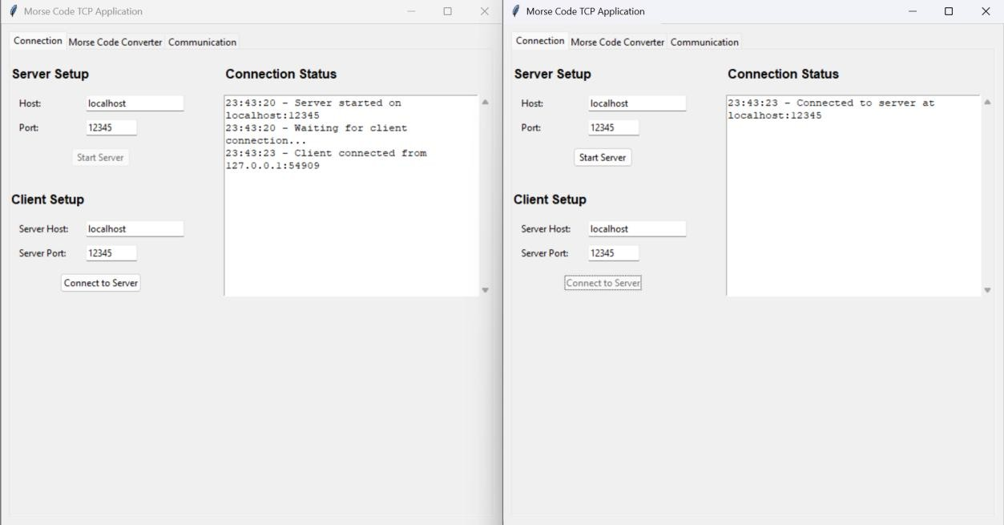

# (Connection between the server and the Client)

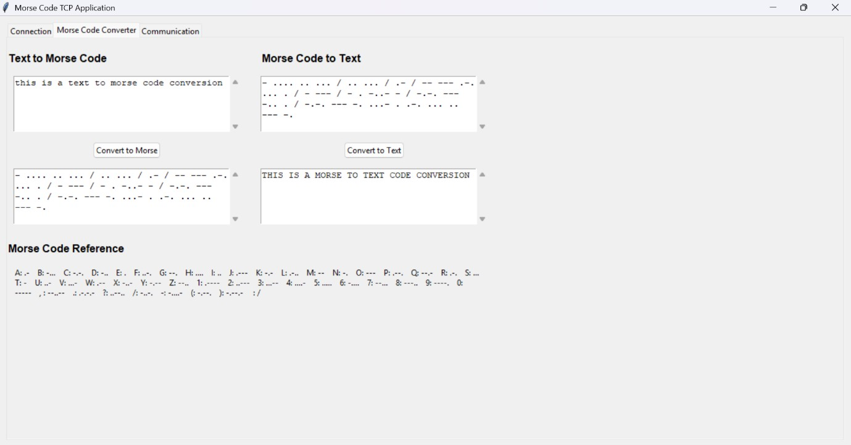

# (Morse to Text and Text to Morse conversion )

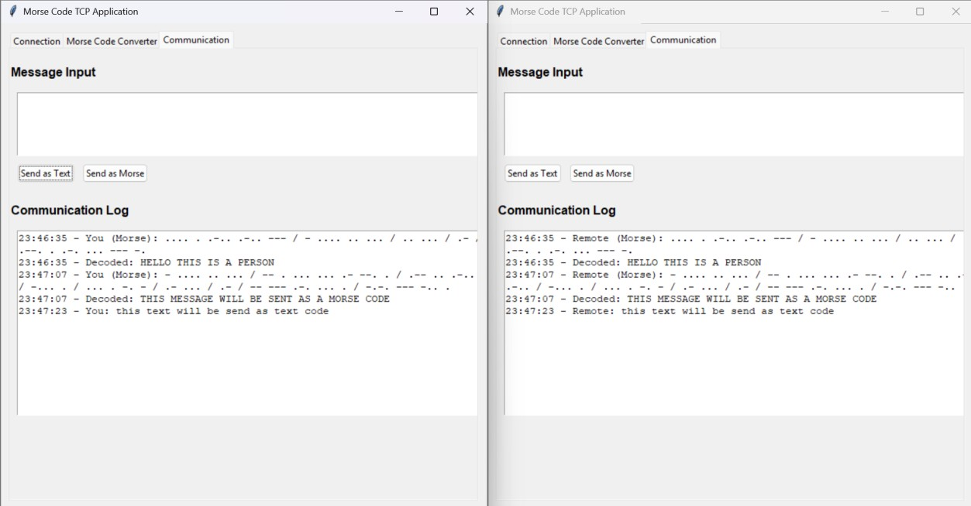

**(Communication Logs between 2 instances as we sent any messages just like in chat app but here, we can send them in morse code as well as in text)**

# 7. Future Scope

The Morse Code TCP Application lays a solid foundation for combining classic communication systems with modern networking technologies. Moving forward, several enhancements can be considered to expand the application's capabilities and reach:

## 7.1 Enhanced Security

* **Encryption**: Implement end-to-end encryption (e.g., AES) to secure messages during transmission.
* Authentication: Add user authentication mechanisms to restrict unauthorized access.

## 7.2 Advanced Communication Features

* **Group Messaging**: Support multi-client communication with group chat functionality.
* **File Transfer**: Add functionality to send files or images over the TCP connection.

# 8. Conclusion

The Morse Code TCP Application successfully combines historical communication methods with modern networking technology, providing both educational value and practical functionality. The project demonstrates effective implementation of socket programming, multi-threading, and graphical user interface design in Python.

The modular architecture ensures extensibility for future enhancements, while the intuitive interface makes the application accessible to users with varying levels of technical expertise. This project serves as a practical example of how traditional communication techniques can be integrated into contemporary software applications.